UML DIAGRAM JAGO SHOLAT



Dipersiapkan oleh:

DUG LEGIR ( D3IF-40-02)

Muhammad Faisal Amir (6706160014)

Bryan Rafsanzani (6706160065)

Muh. Ikhsan Ramadhan (6706162062)

D3 TEKNIK INFORMATIKA

TELKOM UNIVERSITY

JL. Telekomunikasi No. 01 Terusan Buah Batu, Bandung

* ER DIAGRAM

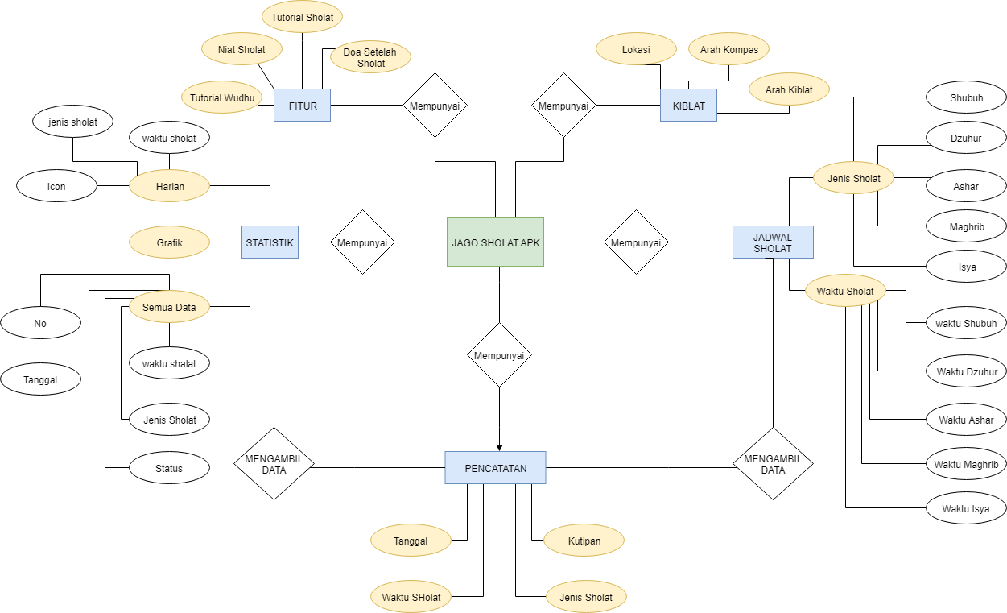

* USE CASE DIAGRAM

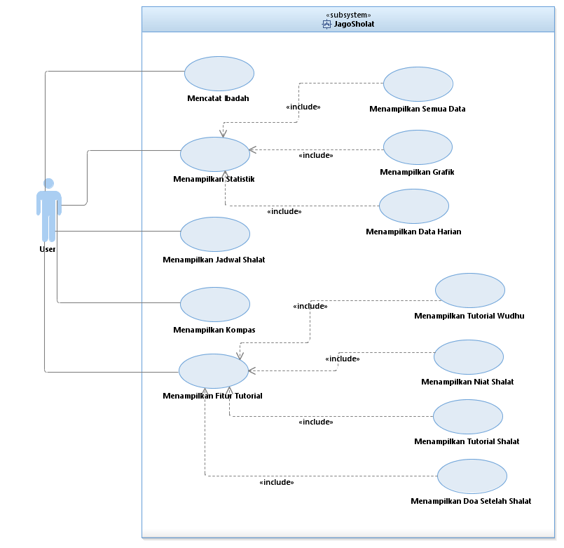

* CLASS DIAGRAM

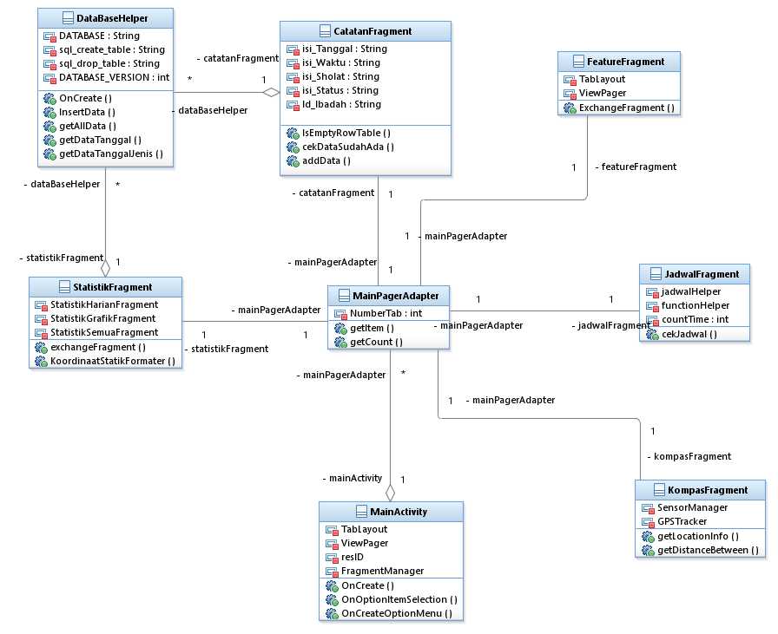

* SQUENCE DIAGRAM

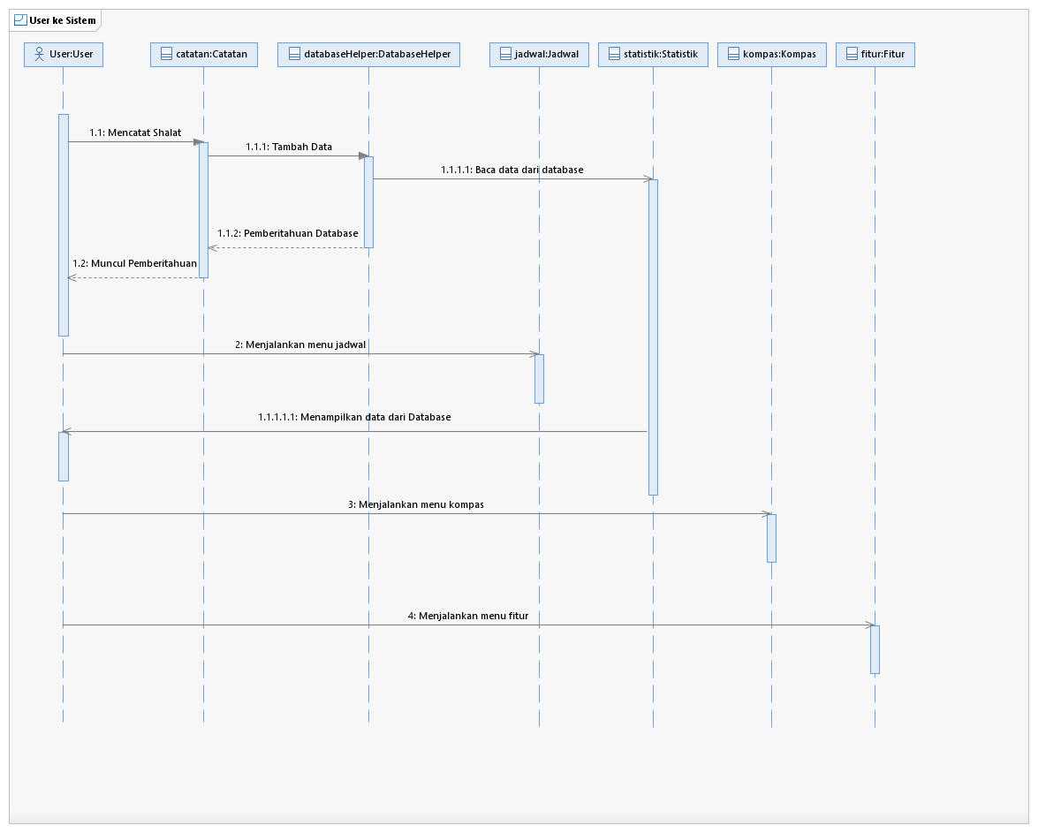

* COMMUNICATION DIAGRAM

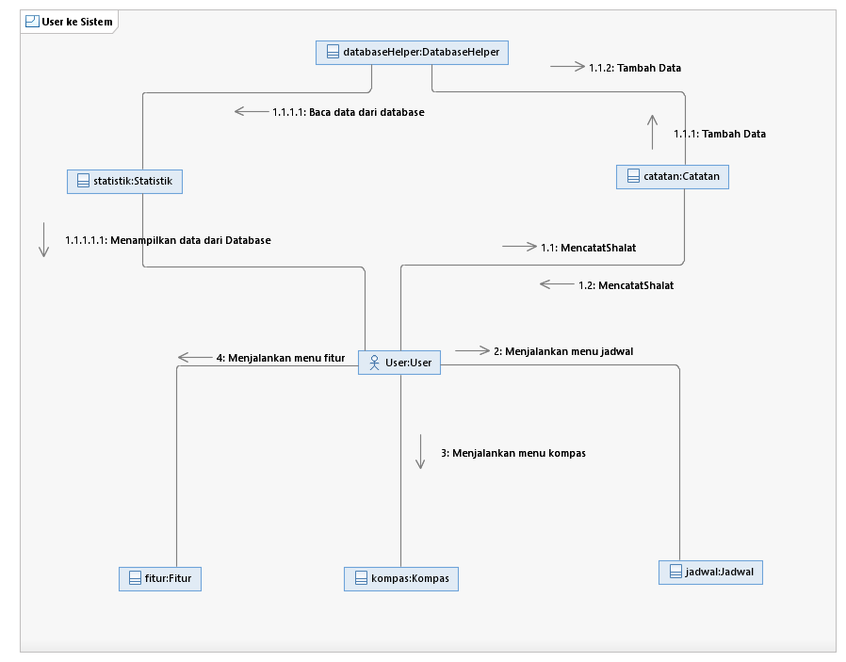

* ACTIVITY DIAGRAMs

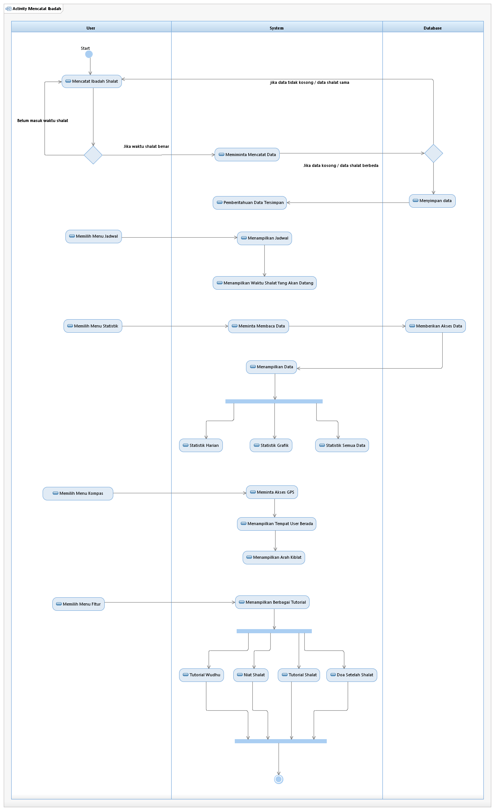

* STATE MACHINE DIAGARAM

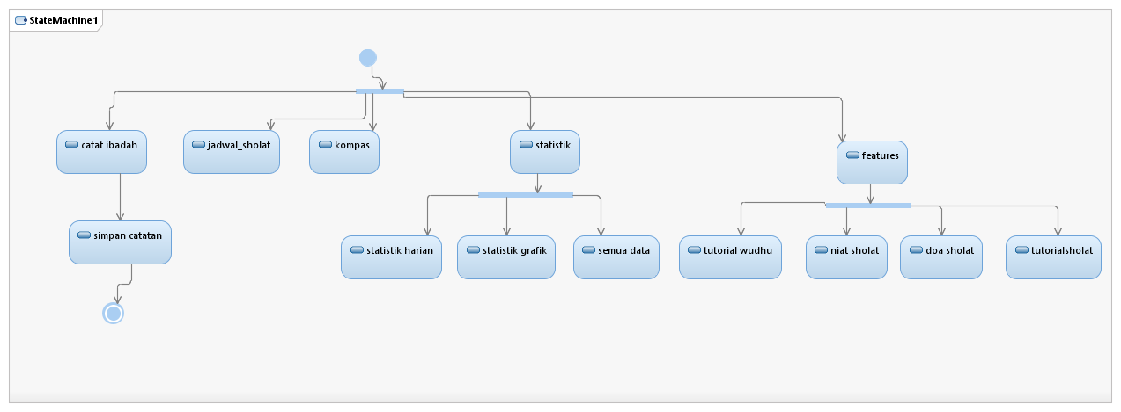

* COMPONENT DIAGRAM

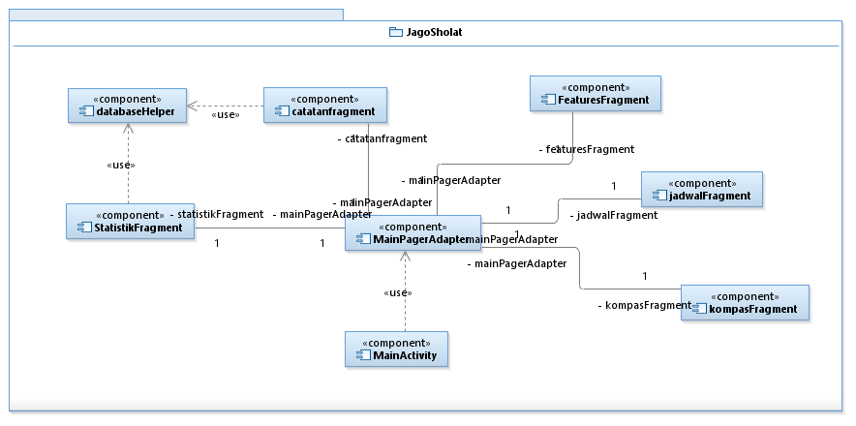

* DEPLOYMENT DIAGRAM